

Sri Lanka Institute of Information Technology

**E-Commerce System**

Information Technology Project Management (IT 3030)

2019

**Project ID: Group 405-G7**

Final Project Report

Submitted By:

* + - * + IT 17063769 Mahawatta D.K.
        + IT 17114004 Thalagahagedara T.M.S.S.B.
        + IT 17097734 Abimani R.M.K.C.
        + IT 17106566 Wijesinghe D.S.D.
        + IT 17103114 Tissera W.S.

Table of Contents

**1. Members’ Details and Work Lord1**

**2. Functional / Non-Functional Requirement2**

**3. SE methodologies/Methods3**

4. Clickable Link3

5. Appendix (References)

Appendix 1: Onion Diagram4

Appendix 2: Activity Diagram5

**Appendix 3: Use Case Diagram6**

**Appendix 4: Overall Architecture7**

**Appendix 5: Class Diagram (Other diagrams) 8**

**Appendix 6: Gantt chart9**

1. ***Members’ Details and Workload Allocation***

|  |  |  |  |
| --- | --- | --- | --- |
| **Description of Function** | **Registration Number and Name of Developer** | | **Role** |
| **IT Number** | **Name** |  |
| * User Login |  |  |  |
| * User Login Validation |  |  |  |
| * User Registration | IT17103114 | W.S.Tissera | User Management |
| * User Details View |  |  |  |
| * Update and Delete Users |  |  |  |
|  |  |  |  |
| * Add Post |  |  |  |
| * View Post | IT17097734 | R.M.K.C. Abimani | Inventory |
| * Update Post |  |  |  |
| * Delete Post |  |  |  |
|  |  |  |  |
| * Add Payment Settings |  |  |  |
| * View Payment Details | IT17114004 | T.M.S.S.B thalagahagedara | Payment |
| * Update details |  |  |  |
| * Delete payment Details |  |  |  |
|  |  |  |  |
| * Add Shipping Companies |  |  |  |
| * View Companies | IT17106566 | D.S.D.Wijesinghe | Shipping Management |
| * Update Companies Details |  |  |  |
| * Delete Companies |  |  |  |
|  |  |  |  |
| * Admin Login |  |  |  |
| * Admin Login Validate |  |  |  |
| * Add Items to Cart |  |  | Cart and Orders |
| * View Cart Items | IT17063760 | D.K.Mahawatta |  |
| * Update Cart Items |  |  |  |
| * Delete Cart Items |  |  |  |

1. ***Requirements***

|  |  |  |  |
| --- | --- | --- | --- |
|  | Functional Requirement | Non- Functional Requirement | Technical Requirement |
| Order and Cart | Add items to the shopping cart**,** Delete added items**,** Update shopping cart | Scalability**,** Capacity**,** Availability**,** Reliability**,**  Recoverability**,**  Maintainability**,**  Serviceability | Facility for user to update/delete their shopping cart when they want to do an any change of order**,** View customer’s order details quickly and clearly |
| Payment | Login**,** View existing payments**,** View payments reports**,** Check payment status | Performance**,** Response time**,** Security and privacy**,** Interface requirements**,** Maintainability requirements | Well supported, Facility for users to change their own password**,** if they don’t know the old password |
| Inventory | Log in**,** Change password**,** View inventory items**,** Search items**,** Cancel receipt**,** Produce receipt**,** View sold items**,** Check stock**,** Check inventory status | Performance**,** The response time**,** Security and privacy**,** Availability**,** Scalability**,** Capacity | Well-supported, High availability/reliability**,** User can change their own password**,** Opportunity to configure with password expiration history and intruder lockout |
| User Management | Login**,** View accounts details**,** View Accounts Receivable**,** Fix accounts | Scalability**,** Capacity**,** Availability**,** Reliability**,** Environmental**,** Data Integrity**,** Usability**,** High security | High reliability**,** Accessibility**,** Adaptability**,** User friendly |
| Shipping Management | View shipping companies**,** Add shipping companies | Scalability**,** Capacity**,** Availability**,** Reliability**,** Recoverability**,** Serviceability. | User friendly**,** Well supported**,** High availability |

1. ***SE Methods/Methodologies***

**Agile Model**

**Description**

Agile SDLC model is a combination of iterative and incremental process models with focus on process adaptability and customer satisfaction by rapid delivery of working software product. Agile Methods break the product into small incremental builds. These builds are provided in iterations.

**The usage**

* Iterative process of plan, develop and deploy to meet the changing client needs while ensuring fast development of prototypes Software development technologies and tools are well-known.
* Set of engineering best practices that allow for rapid application development and delivery.

**Advantages**

* Customer satisfaction by rapid, continuous delivery of useful software.
* People and interactions are emphasized rather than process and tools. .
* Customers, developers and testers constantly interact with each other.

**Disadvantages**

* In case of some software deliverables, especially the large ones, it is difficult to assess the effort required at the beginning of the software development life cycle.
* Lack of emphasis on necessary designing and documentation.

1. ***Clickable Link (VCS repo)***

* <https://github.com/dilummahawatta/pafProject.git>

# Appendix

Appendix 1: Onion Diagram

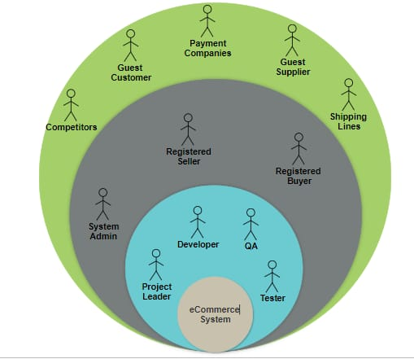

Appendix 2: Activity Diagram

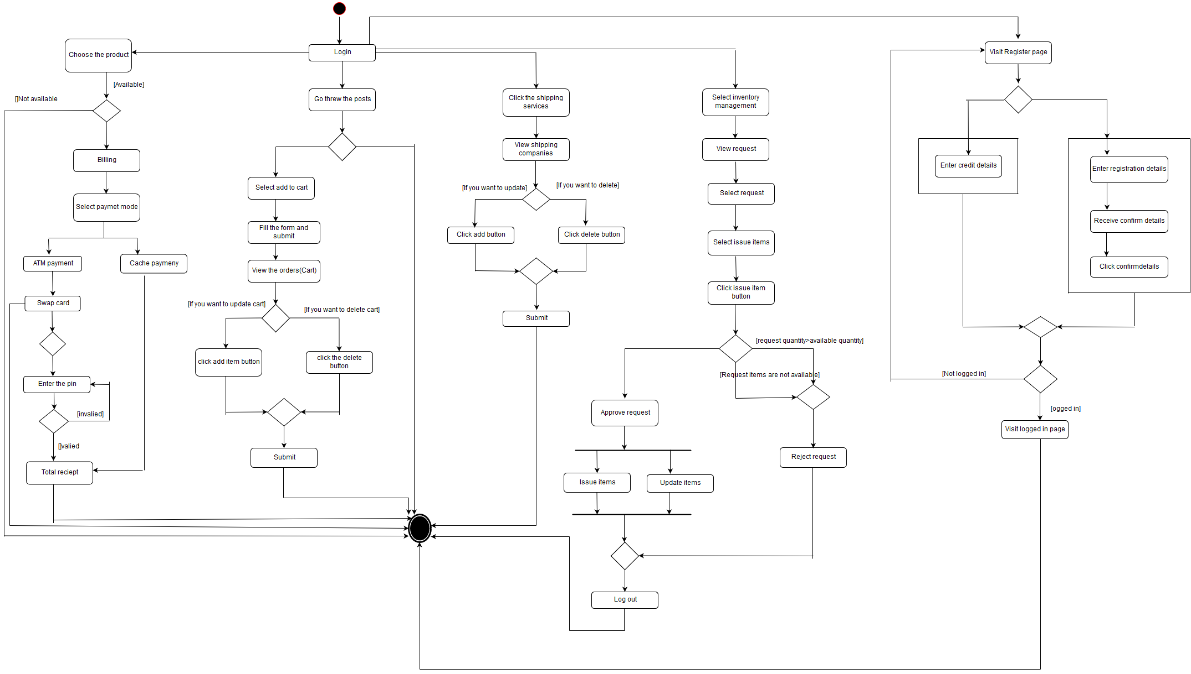

Appendix 3: Use Case Diagram

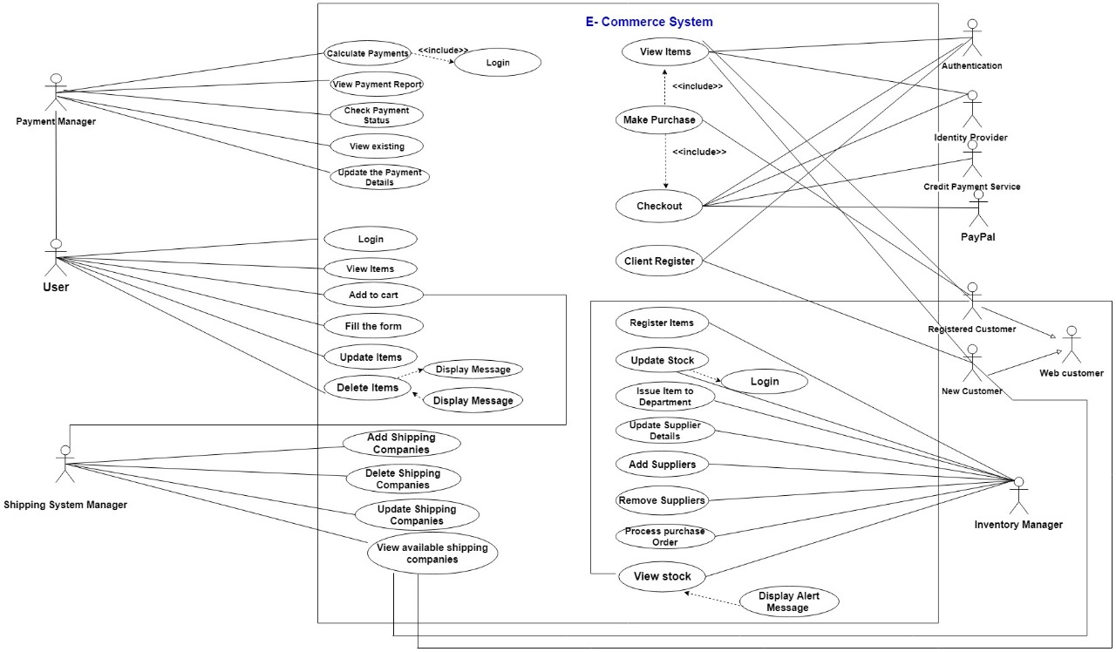

Appendix 4: Overall Architecture

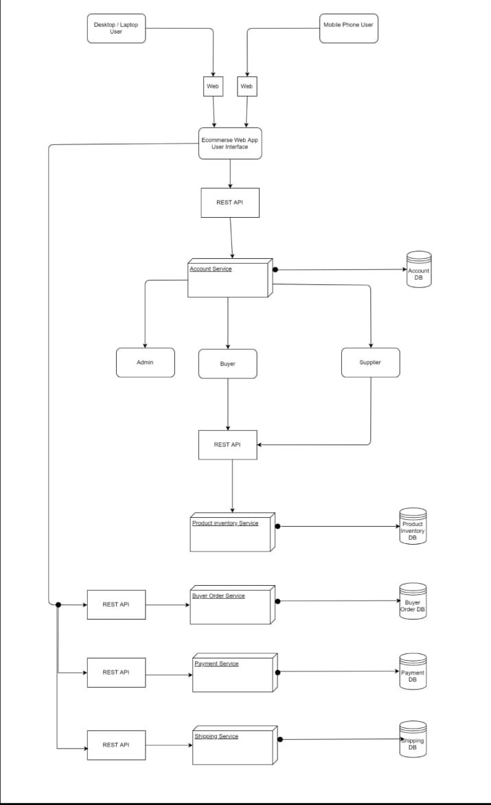

Appendix 5: Class Diagram (Other Diagram)

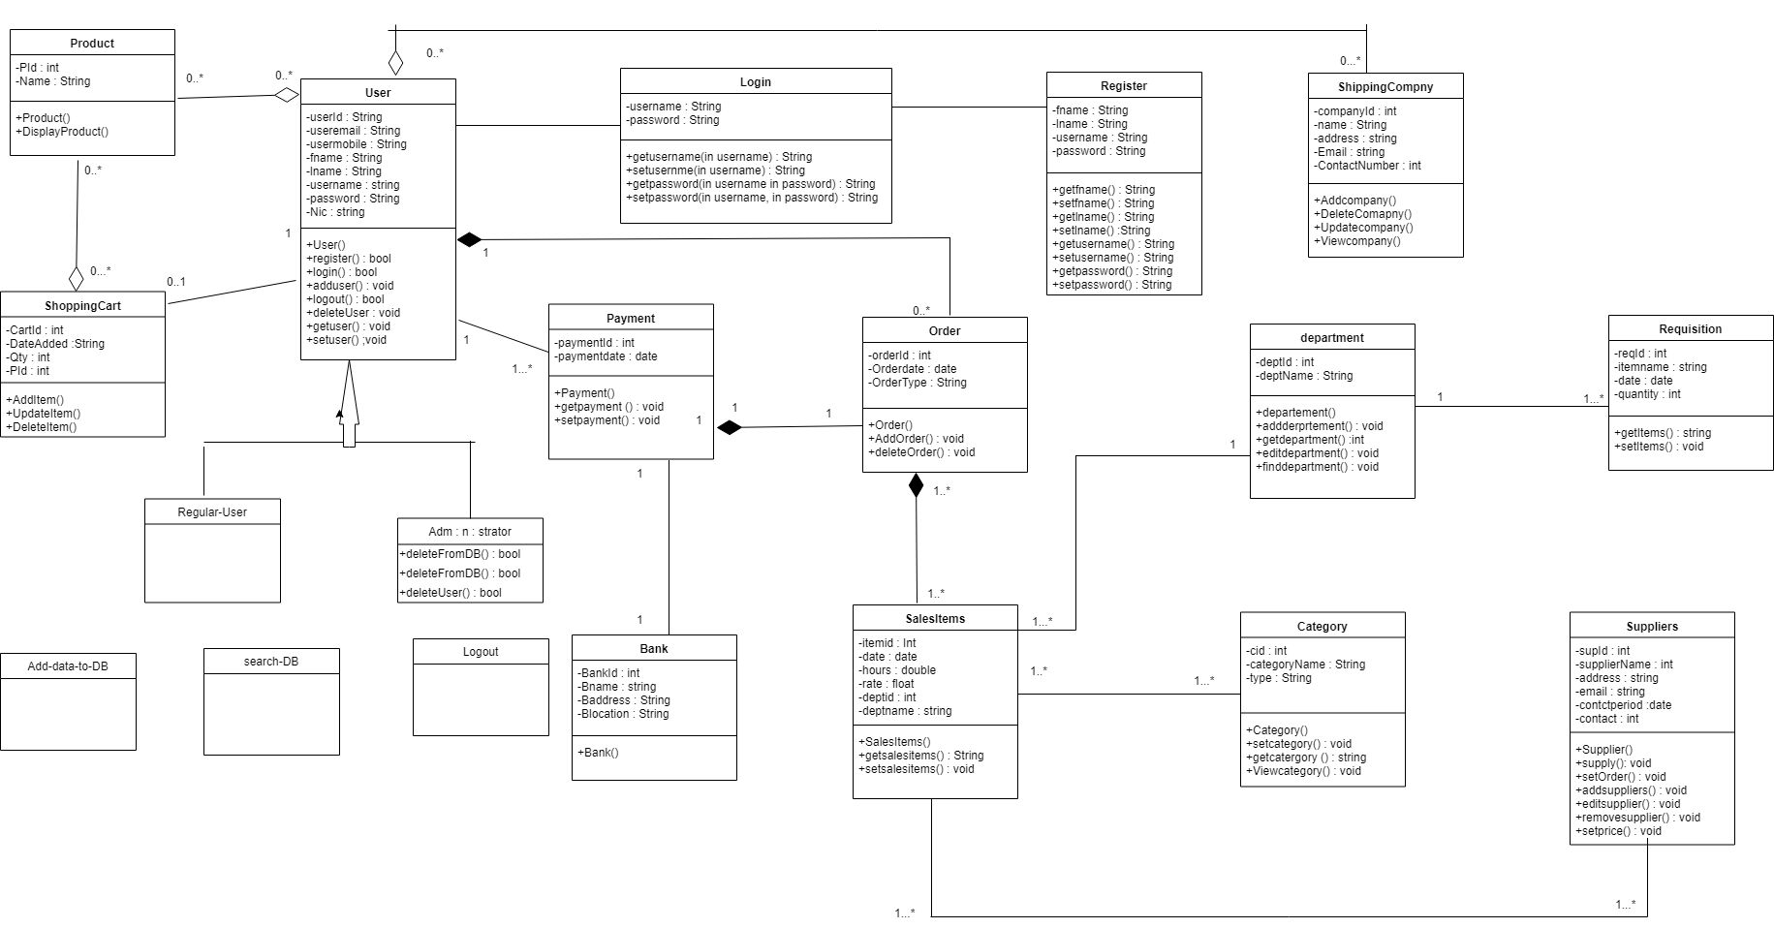

Appendix 6: Gantt chart

